1)Scenario is I make changes in one container inside of the index file it reflects synced all containers made change using mount the local volume

2)we want one ec2 ubyntu server so we go to launch then login to putty

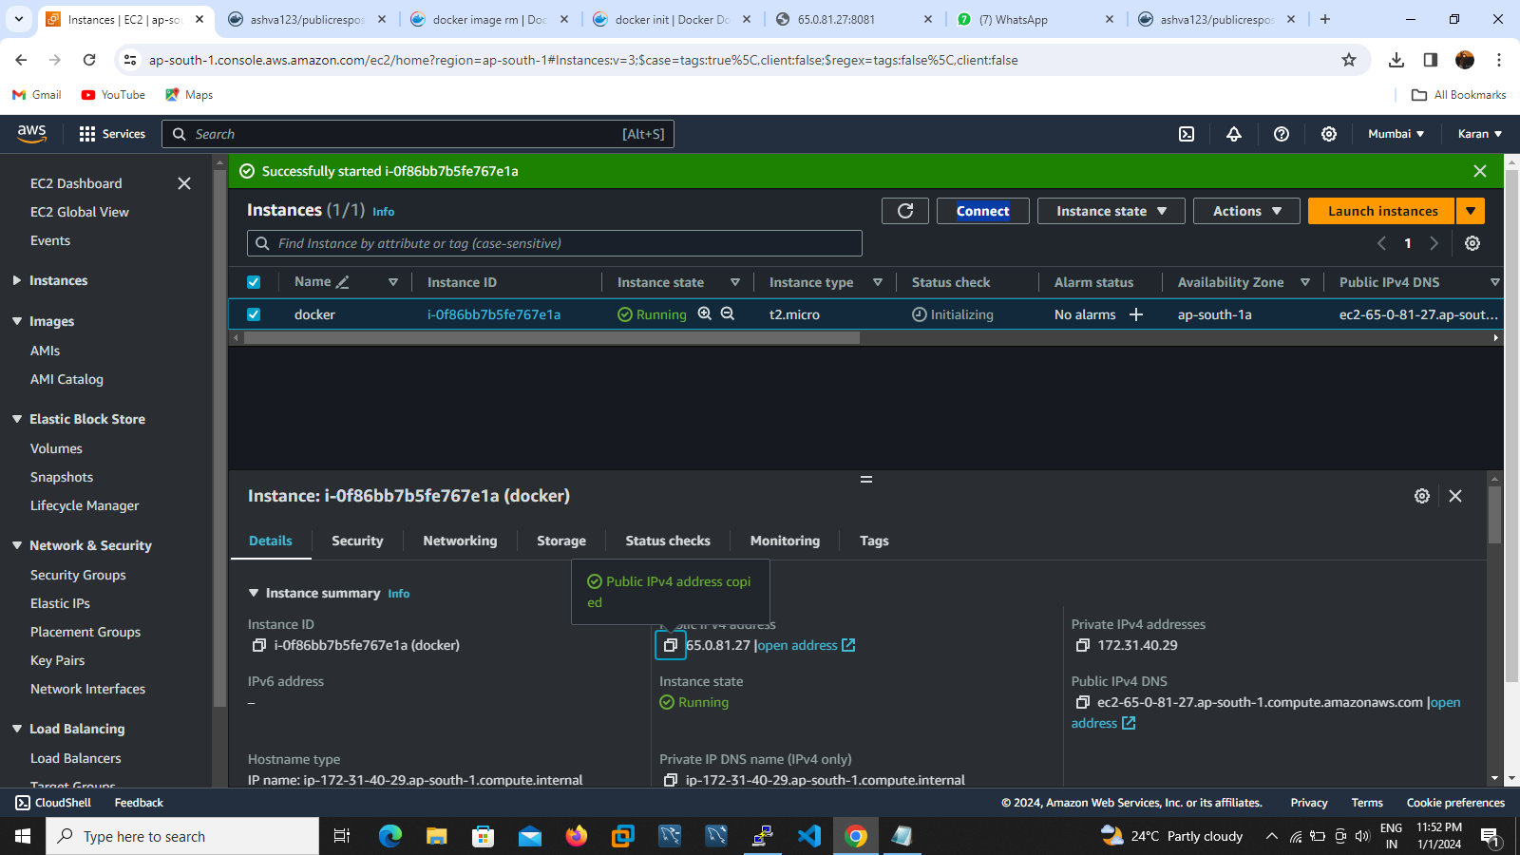

3) After install docker application using ubuntu packaging commands apt-get install docker.io –y .

4) apt-get update to update your environment

5) docker volume ls execute to check any volumes are available

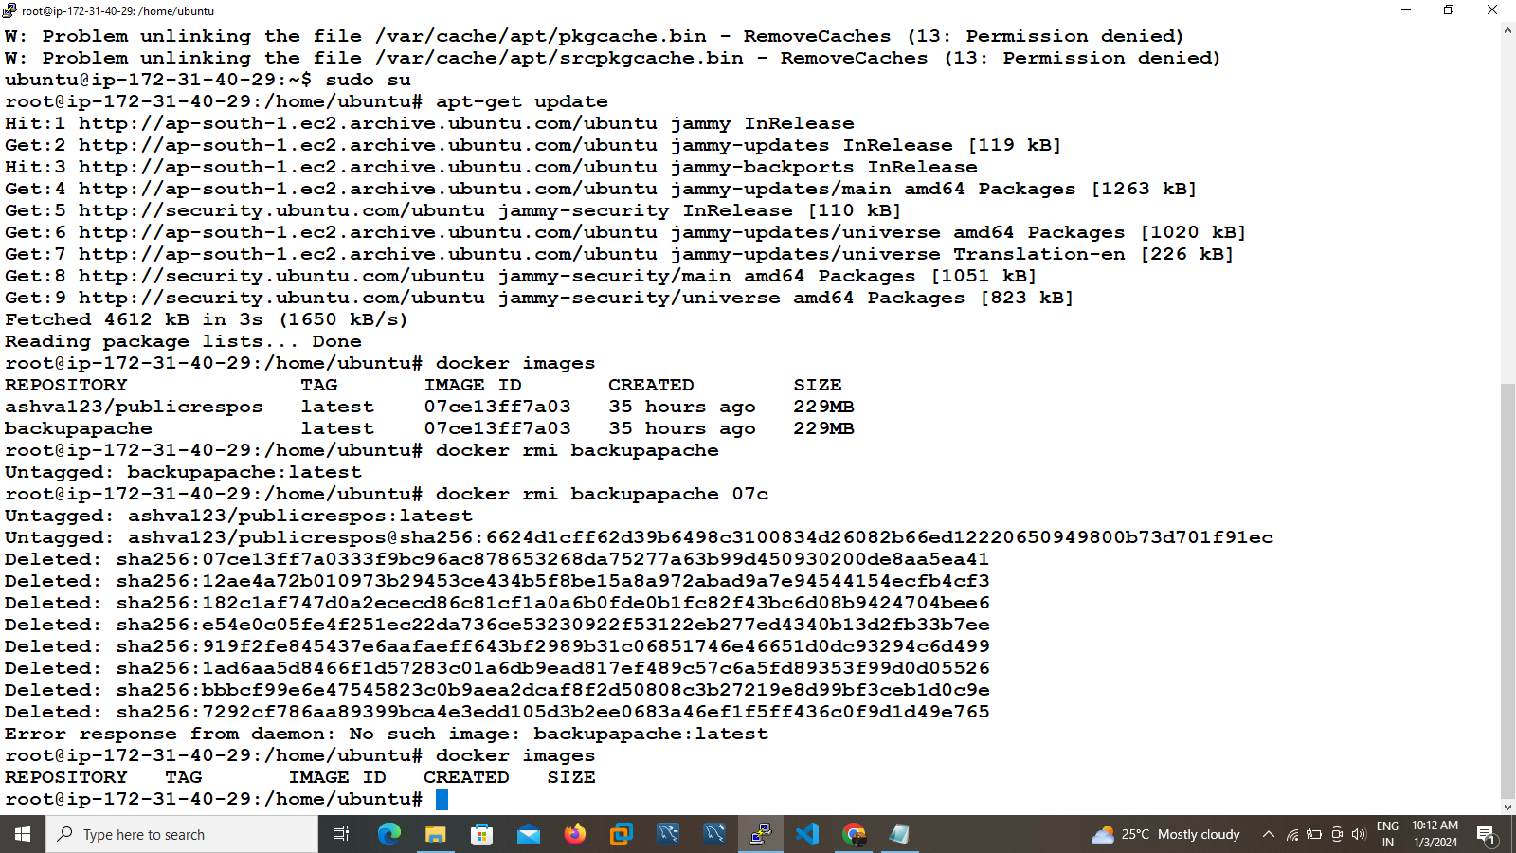

6) docker volume create myvolume create one volume

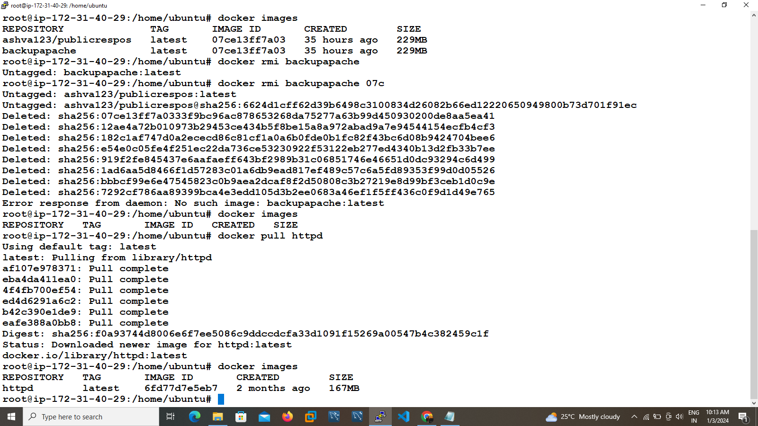

7) docker inspect myvolume to check the mounding directory path

[

{

"CreatedAt": "2024-01-03T05:21:50Z",

"Driver": "local",

"Labels": null,

"Mountpoint": "/var/lib/docker/volumes/myvolume/_data",

"Name": "myvolume",

"Options": null,

"Scope": "local"

}

]

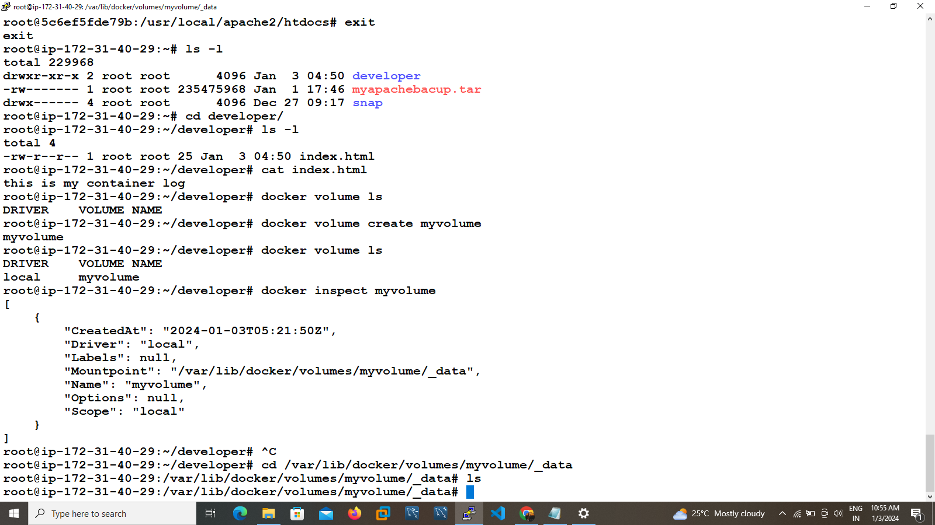

4)go to the directory cd "/var/lib/docker/volumes/myvolume/_data",

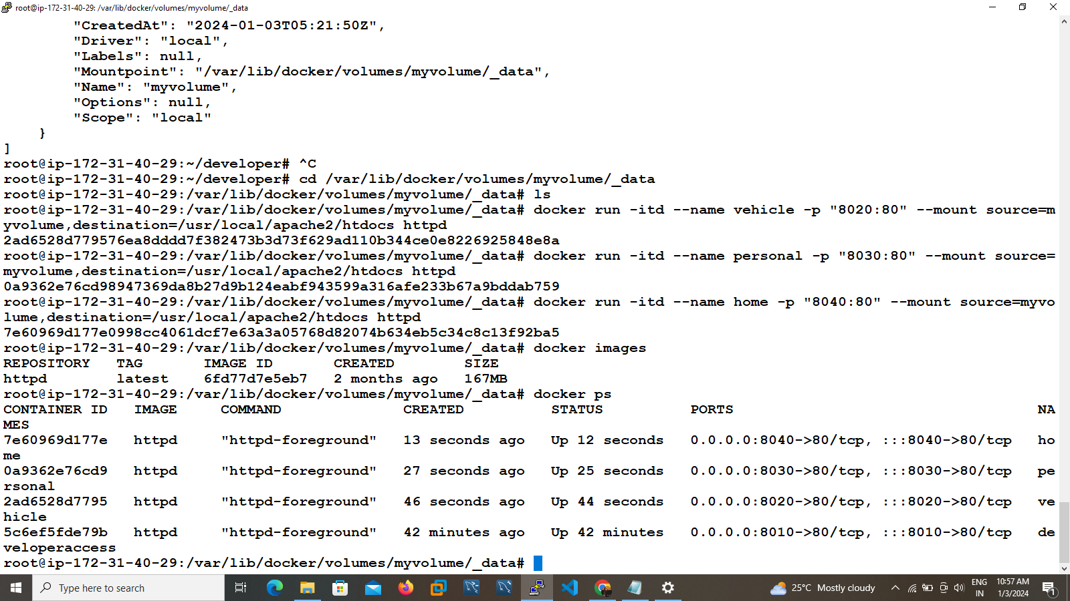

5)execute 3 container with mount there

Examble : docker run -itd --name vehicle -p "8020:80" --mount source=myvolume,destination=/usr/local/apache2/htdocs httpd

6)then go to change in any container index file its reflects other containers also

